UNIVERSITY OF PETROLEUM AND ENERGY STUDIES


Student Name: Deepanshi Shukla
Sap ID: - 590021964
Batch: B10
Course: B. Tech (CSE)
SUBJECT: python Programming lab
Experiment: 5
Submitted to:
Kamakshi Rautela

Python Programming Laboratory
Experiment 5: Lists, tuples, dictionary
1.Scan n values in range 0-3 and print the number of times each value has occurred.
Code:
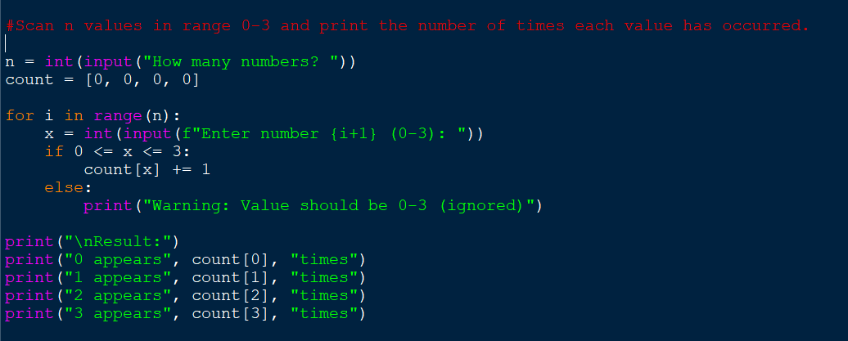
Output:
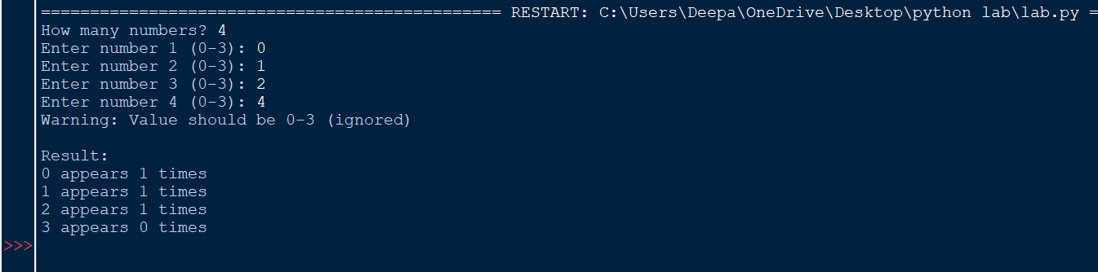
2. Create a tuple to store n numeric values and find average of all values.

Code:
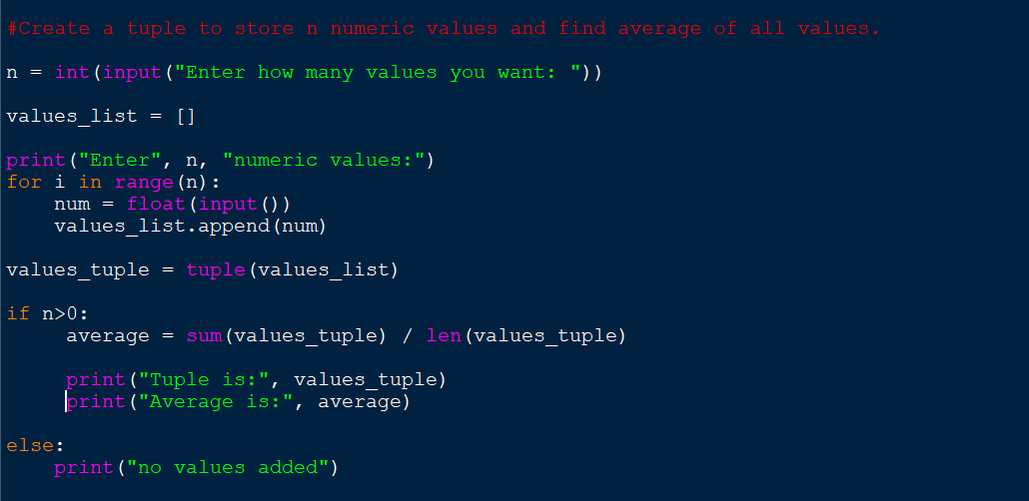
Output:
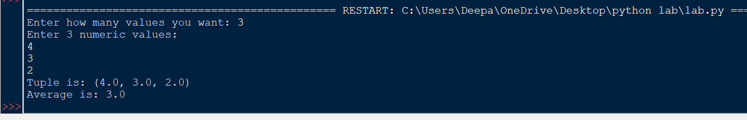
3. WAP to input a list of scores for N students in a list data type. Find the score of the runner-up and print the output.
Sample Input
N = 5
Scores= 2 3 6 6 5
Sample output
5
Note: Given list is [2, 3, 6, 6, 5]. The maximum score is 6, second maximum is 5. Hence, we print 5 as the runner-up score
Code:
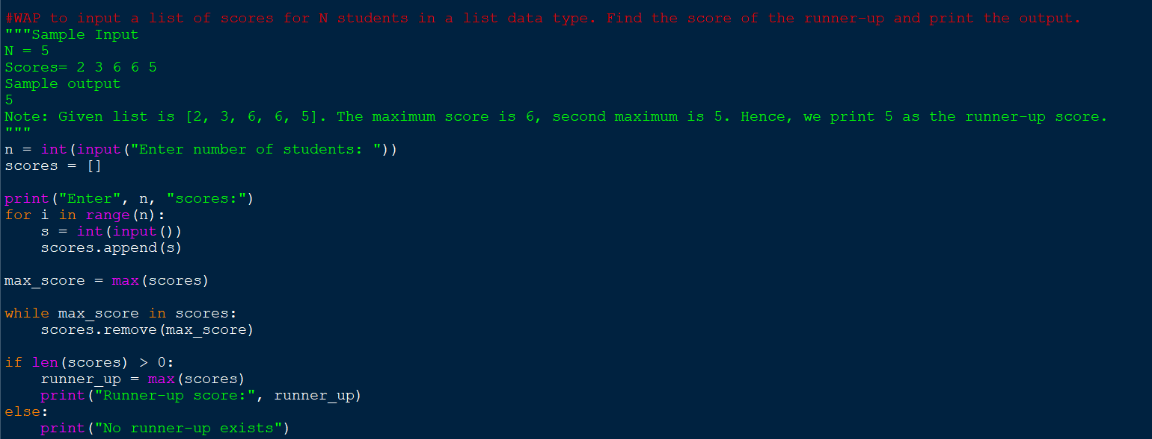
Output:
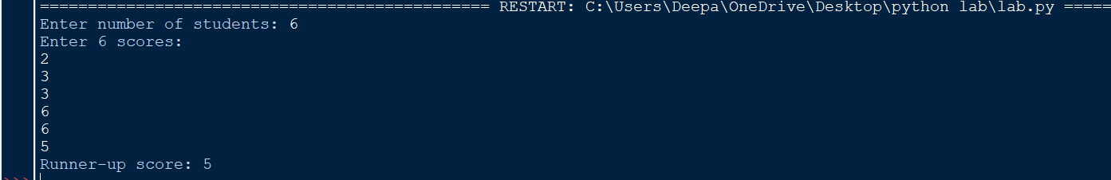
4. Create a dictionary of n persons where key is name and value is city.
a) Display all names
b) Display all city names
c) Display student name and city of all students.
d) Count number of students in each city.
Code: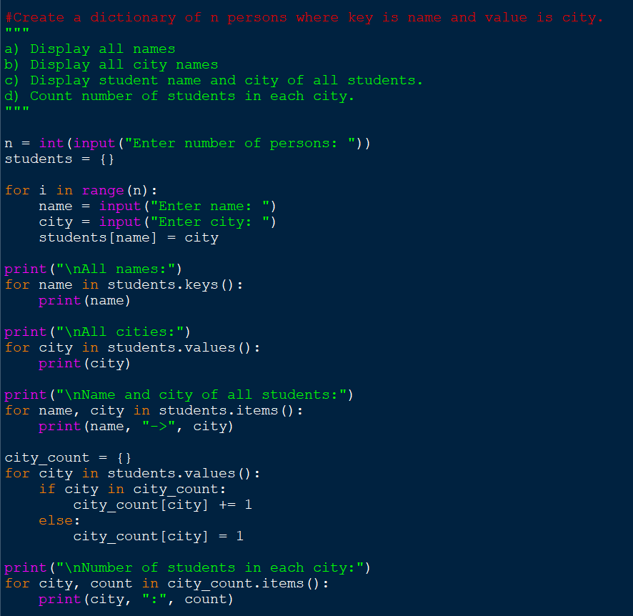

Output:
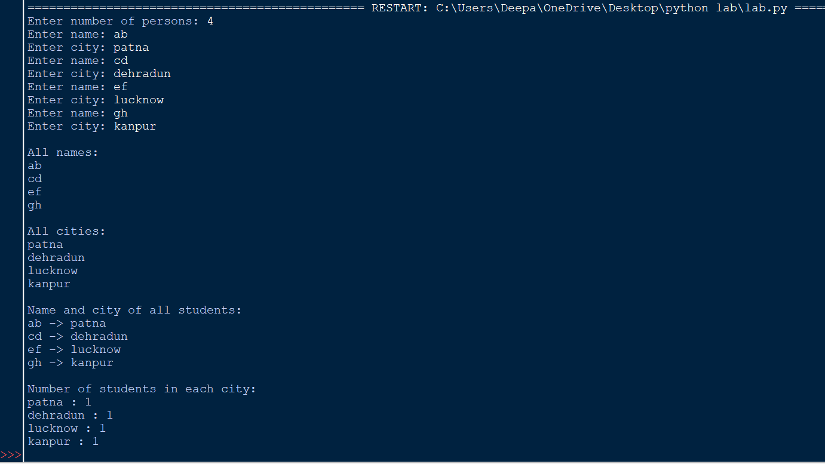
5.Store details of n movies in a dictionary by taking input from the user. Each movie must store details like name, year, director name, production cost, collection made (earning) & perform the following :-
a) print all movie details
b) display name of movies released before 2015
c) print movies that made a profit.
- d) print movies directed by a particular director.

Code:
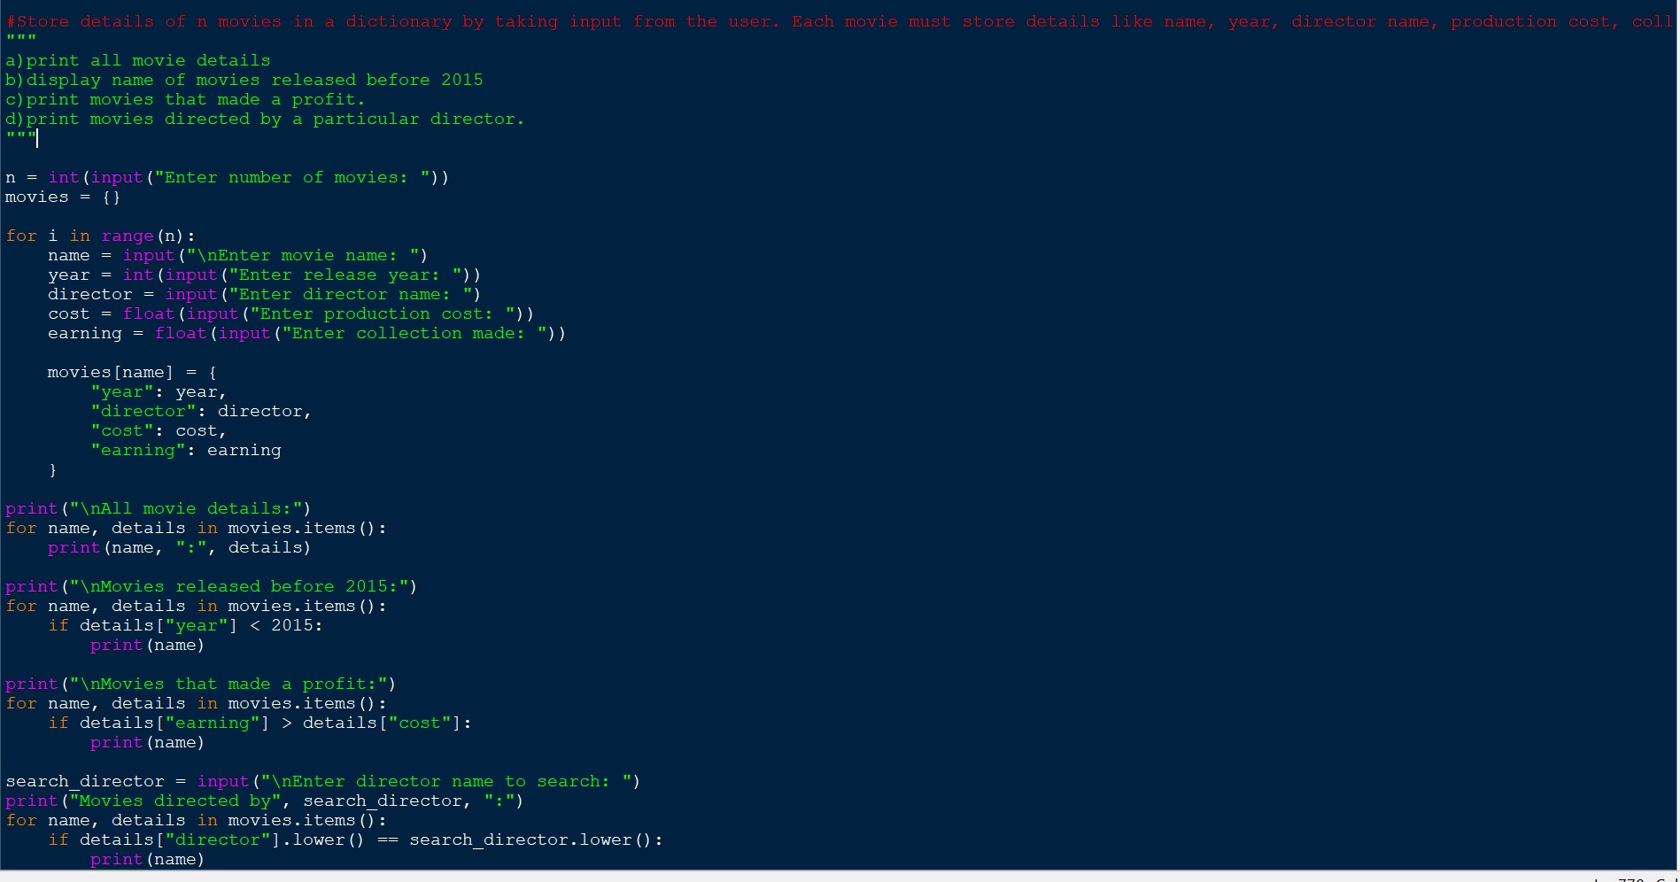
Output: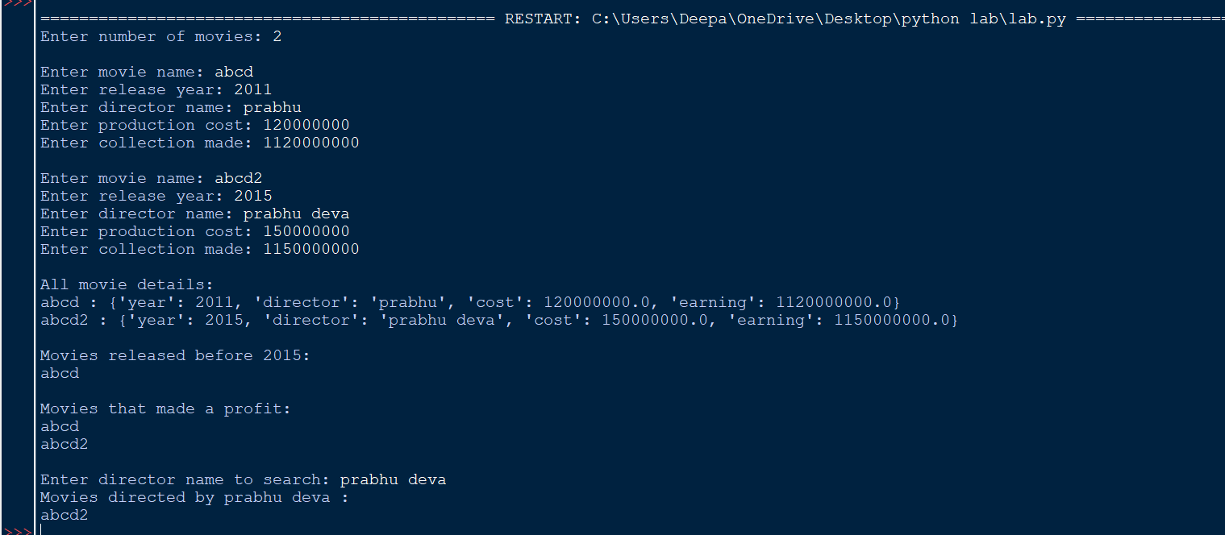
6. Create a contact book where users can store, search, update, and delete contacts. Use dictionary for storing contacts.

Code: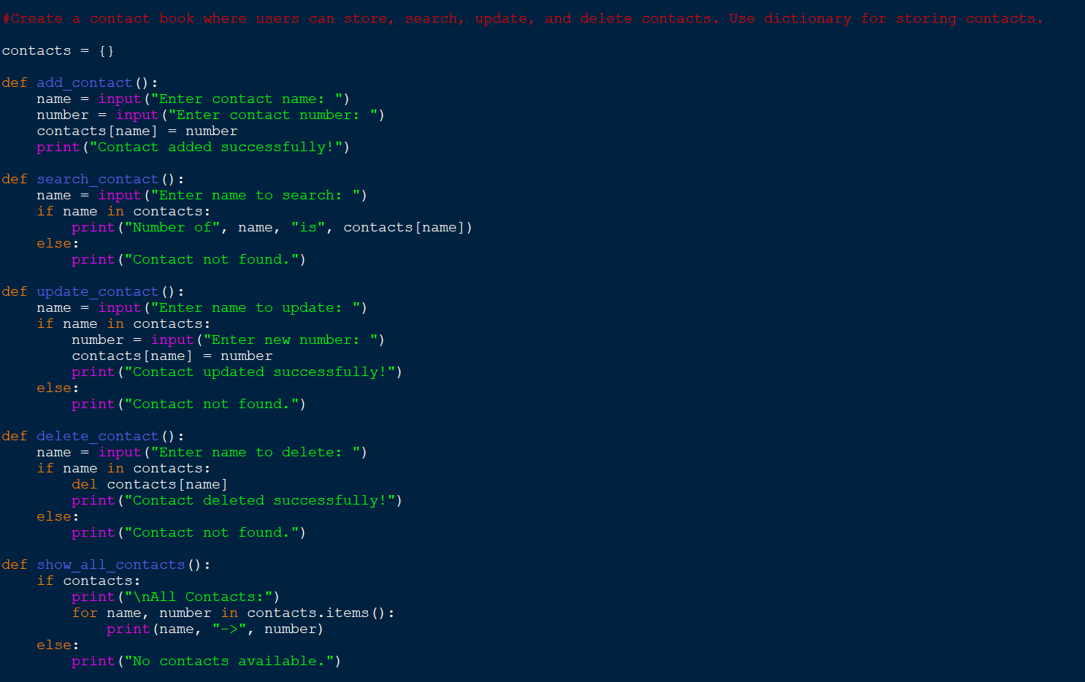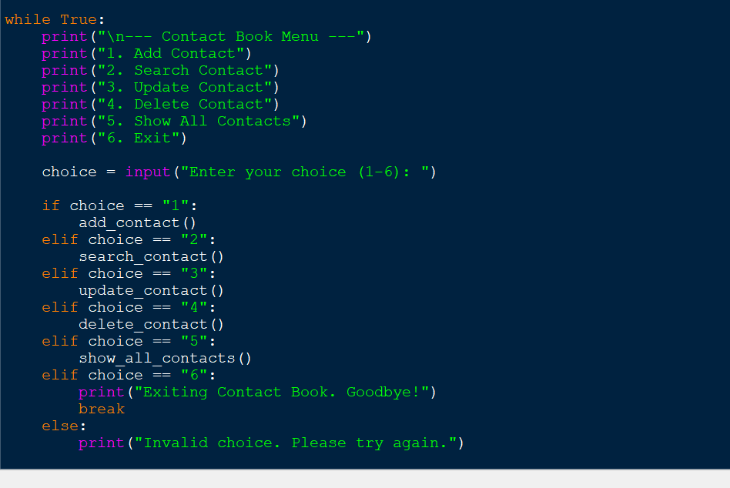

Output:
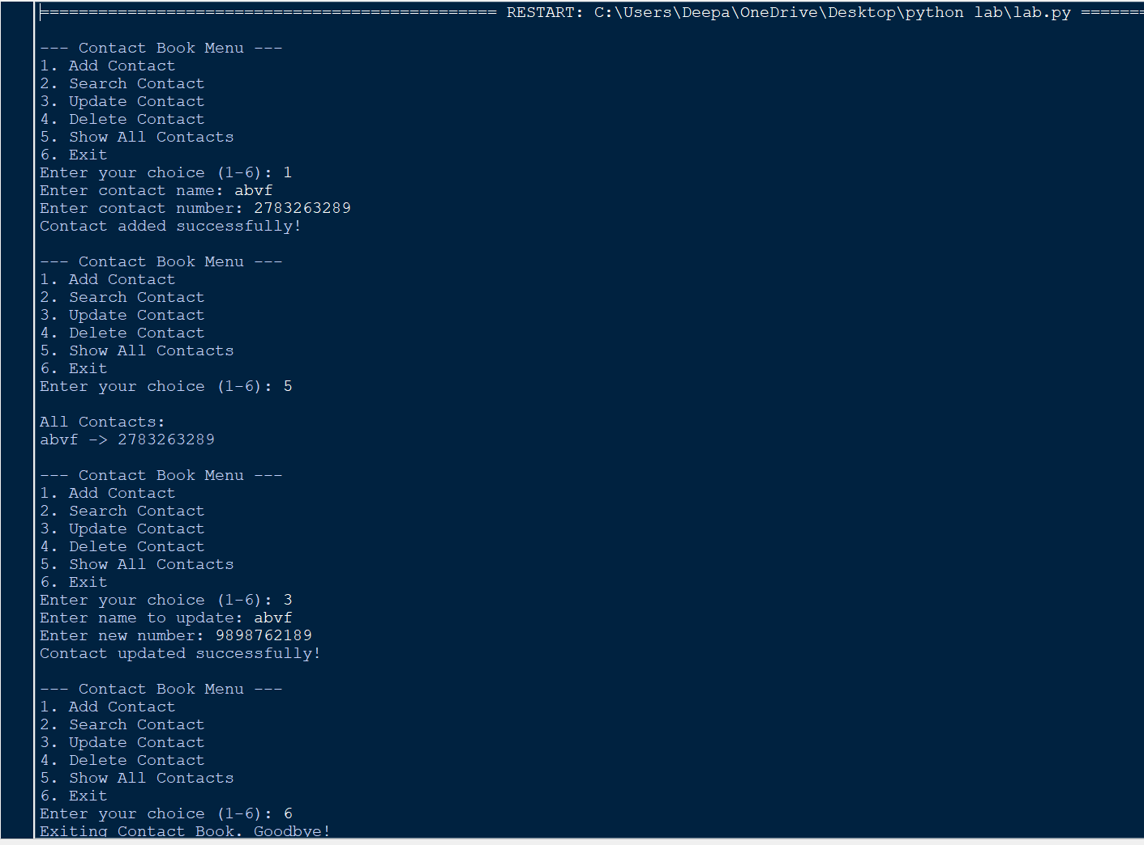
7. Create a Todo list Manager where users can add, view, and remove tasks. Use List for storing tasks.
Code: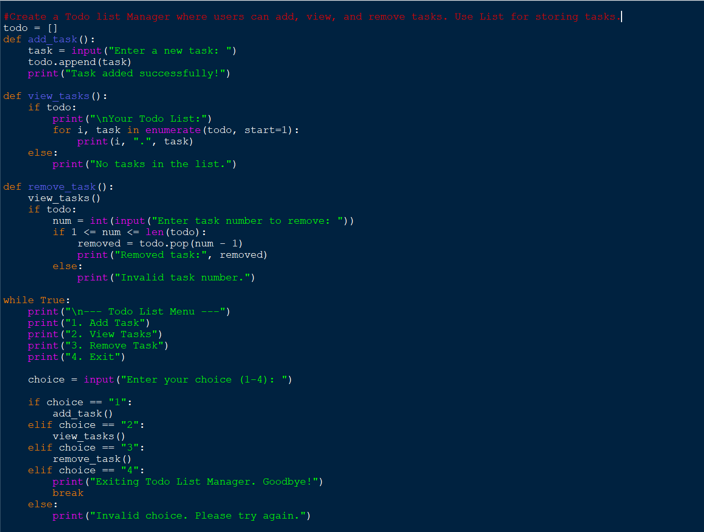

Output:
